|  |  |
| --- | --- |
|  | **MINISTRY OF EDUCATION AND TRAINING** |

**FPT UNIVERSITY**

|  |  |
| --- | --- |
| Capstone Project Document | |
| **Face Detection For Delivery Payment** | |
| **Group 5 - IS** | |
| **Group members** | Nguyễn Văn Hiếu – SE61961 (Leader)  Đinh Phú Thắng – SE62528  Trần Trọng Nghĩa – SE62278  Nguyễn Hữu Lâm– SE61234 |

– **Ho Chi Minh City, 20 January 2019** –

# **D. Report No. 4 Software Design Description**

# **1. Design Overview**

- This document describes the technical and user interface design of MSSC System. It includes the architectural design, the detailed design of common functions and business functions and the design of database model.

- The architectural design describes the overall architecture of the system and the architecture of each main component and subsystem.

- The detailed design describes static and dynamic structure for each component and functions. It includes class diagrams, class explanations and sequence diagrams for each use cases.

- The database design describes the relationships between entities and details of each entity.

- Document overview:

* Section 2: gives an overall description of the system architecture design.
* Section 3: gives component diagrams that describe the connection and integration of the system.
* Section 4: gives the detail design description which includes class diagram, class explanation, and sequence diagram to details the application functions.
* Section 5: describe screens design.
* Section 6: describe a fully attributed ERD.
* Section 7: describe algorithms.

# **SystemArchitecture 2. System Architectural Design**

Figure System Architectural Design

## **2.1 Web application architecture description**

* In web application, the system is developed under MVC architecture style. We choose this architecture for Web application because of following advantages:
  + - Business code is separated with View and Controller that make easy to maintain and easy to understand.
    - Model is used to get and update data from database.
    - Controller takes request from web browser and makes a call to business logic layer.

**2.2 Mobile application architecture description**

* The activity in Mobile client act like a controller to redirect command from view in mobile.
* It takes HTTP Response from server and makes call HTTP Request.

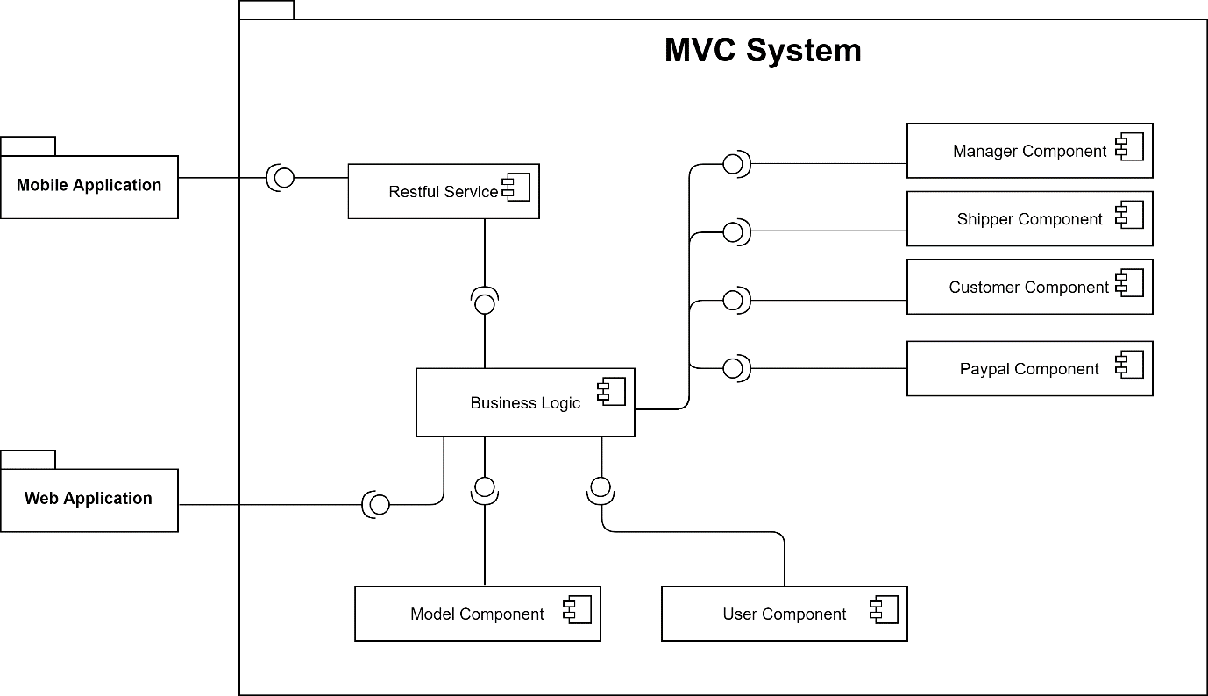

# **3. Component Diagram**

Figure: Component Diagram

|  |  |
| --- | --- |
| **Component Dictionary: Describe component** | |
| **Component Name** | **Description** |
| Mobile Application | Mobile Application package. |
| Web Application | Web Application package: controller, view. |
| Restful Service | Provide API for Mobile Application. |
| Business Logic | Handle business operation for each component. |
| Model Component | Mapping data from database. |
| User Component | Component to handle User activities in the system. |
| Manager Component | Component to handle Manager activities in the system. |
| Customer Component | Component to handle Customer activities in the system. |
| Shipper Component | Component to handle Shipper activities in the system. |
| PayPal Component | Component to handle PayPal activities in the system. |

Table Component Dictionary

# **4. Detail Description**

## **4.1 Class Diagram**

Figure Class Diagram

|  |  |
| --- | --- |
| **Class Dictionary** | |
| **Class Name** | **Description** |
| Payment Type | Abstract class that contains Payment type information. |
| Payment Information | Contain Payment Information |
| Price List | Contain Price List information |
| Role | Contain Role information |
| Account | Contain Account information |
| Shipper | Contain Shipper information |
| Status | Contain Status information |
| Order | Contain Order information |
| Resource | Contain Resource information |
| Order Detail | Contain Order Detail information |
| Town | Contain Town information |
| Store | Contain Store information |
| Product | Contain Product information |
| City | Contain City information |

Table Class Dictionary

## **4.2 Class Diagram Explanation**

### **4.2.1 Payment Type**

**Attribute**

|  |  |  |  |
| --- | --- | --- | --- |
| Attribute | Type | Visibility | Description |
| id | integer | public | Unique identifier of a payment type. |
| type | String | public | Type of Payment |
| name | String | public | Name of payment’s type. |
| description | String | public | Description of payment’s type. |

Table Payment Type Attribute

**Method**

|  |  |  |  |
| --- | --- | --- | --- |
| Method | Return type | Visibility | Description |
| getter() | string | public | get attribute value |
| setter() | void | public | return value of attribute |

Table Payment Type Method

### **4.2.2 Payment Information**

**Attribute**

|  |  |  |  |
| --- | --- | --- | --- |
| Attribute | Type | Visibility | Description |
| id | integer | public | Unique identifier of a payment information. |
| Fr_Account_id | integer | public | Linked to table of account |
| Fr_Payment_Type_id | integer | public | Linked to table of payment type |
| username | String | public | Username of account. |
| password | String | public | Password of account. |

Table Payment Information Attribute

**Method**

|  |  |  |  |
| --- | --- | --- | --- |
| Method | Return type | Visibility | Description |
| getter() | String | public | get attribute value |
| setter() | void | public | return value of attribute |

Table Payment Information Method

### **4.2.3 Account**

**Attribute**

|  |  |  |  |
| --- | --- | --- | --- |
| Attribute | Type | Visibility | Description |
| id | integer | public | Unique identifier of account. |
| Phone_number | String | public | Phone number of account. |
| Fr_Role_id | integer | public | Linked to table of role. |
| password | String | public | Password of account. |
| name | String | public | Full name. |
| email | String | public | Email of account. |
| extra_point | integer | public | Extra point of account. |
| report_point | integer | public | Report point of account |
| user_image | Longblob | public | Image of account. |
| nation_id | String | public | Nation Id Card of account. |
| nation_id_created_date | Bigint | public | Create Date of Nation Id Card |
| date_of_birth | Bigint | public | Brithday of account. |
| create_time | Bigint | public | Create time of account. |
| update_time | Bigint | public | Update time of account. |
| delete_time | Bigint | public | Delete time of account. |
| note | String | public | Note of account. |
| status | integer | public | Status of account. |
| editor_id | integer | public | Id of editor’s account. |
| avatar | Longblob | public | Avatar of account. |

Table Account Attribute

**Method**

|  |  |  |  |
| --- | --- | --- | --- |
| Method | Return type | Visibility | Description |
| getter() | string | public | get attribute value |
| setter() | void | public | return value of attribute |

Table Account Method

### **4.2.4 City**

**Attribute**

|  |  |  |  |
| --- | --- | --- | --- |
| Attribute | Type | Visibility | Description |
| id | integer | public | Unique identifier of city. |
| name | String | public | Name of city. |
| postal_code | String | public | Postal code of city |

Table City Attribute

**Method**

|  |  |  |  |
| --- | --- | --- | --- |
| Method | Return type | Visibility | Description |
| getter() | string | public | get attribute value |
| setter() | void | public | return value of attribute |

Table City Method

### **4.2.5 District**

**Attribute**

|  |  |  |  |
| --- | --- | --- | --- |
| Attribute | Type | Visibility | Description |
| id | integer | public | Unique identifier of district. |
| name | String | public | Name of city. |
| Fr_City_id | integer | public | Linked to table of city. |

Table District Attribute

**Method**

|  |  |  |  |
| --- | --- | --- | --- |
| Method | Return type | Visibility | Description |
| getter() | string | public | get attribute value |
| setter() | void | public | return value of attribute |

Table District Method

### **4.2.6 Order**

**Attribute**

|  |  |  |  |
| --- | --- | --- | --- |
| Attribute | Type | Visibility | Description |
| id | integer | public | Unique identifier of order. |
| editor_id | integer | public | Id of editor account. |
| Fr_Account_id | integer | public | Linked to table of account(customer). |
| Fr_Shipper_id | integer | public | Linked to table of shipper. |
| buyer_face | Longblob | public | Face’s Image of customer. |
| bill | String | public | Bill of customer. |
| order_code | String | public | Code of order. |
| total_price | double | public | Total of price. |
| book_time | Bigint | public | Book time of order |
| receive_time | Bigint | public | Receive time of order |
| shipper_earn | double | public | Shipper earn from order. |
| shipper_address | String | public | Address of delivery. |
| Fr_District_id | integer | public | Linked to table of district. |
| longitude | double | public | Longitude of earth. |
| latitude | double | public | Latitude of earth. |
| customer_description | String | public | Description of customer. |
| create_time | Bigint | public | Create time of order. |
| update_time | Bigint | public | Update time of order. |
| delete_time | Bigint | public | Delete time of order. |
| note | String | public | Note of order. |
| status | integer | public | Status of order. |

Table Order Attribute

**Method**

|  |  |  |  |
| --- | --- | --- | --- |
| Method | Return type | Visibility | Description |
| getter() | string | public | get attribute value |
| setter() | void | public | return value of attribute |

Table Order Method

### **4.2.7 Order Detail**

**Attribute**

|  |  |  |  |
| --- | --- | --- | --- |
| Attribute | Type | Visibility | Description |
| id | integer | public | Unique identifier of order detail. |
| Fr_Order_id | integer | public | Linked to table of order |
| Fr_Product_id | integer | public | Linked to table of product |
| unit_price | double | public | Unit_price of product. |
| quantity | integer | public | Quantity of product. |

Table Order Detail Attribute

**Method**

|  |  |  |  |
| --- | --- | --- | --- |
| Method | Return type | Visibility | Description |
| getter() | string | public | get attribute value |
| setter() | void | public | return value of attribute |

Table Order Detail Method

### **4.2.8 Price Level**

**Attribute**

|  |  |  |  |
| --- | --- | --- | --- |
| Attribute | Type | Visibility | Description |
| id | integer | public | Unique identifier of price level. |
| level_name | String | public | Name of price level |
| description | String | public | Description of price level. |
| price | double | public | Price of level. |

Table Price Level Attribute

**Method**

|  |  |  |  |
| --- | --- | --- | --- |
| Method | Return type | Visibility | Description |
| getter() | string | public | get attribute value |
| setter() | void | public | return value of attribute |

Table Price Level Method

### **4.2.9 Product**

**Attribute**

|  |  |  |  |
| --- | --- | --- | --- |
| Attribute | Type | Visibility | Description |
| id | integer | public | Unique identifier of product. |
| Fr_Store_id | integer | public | Linked to table of store. |
| price | double | public | Price of product. |
| product_image | longblob | public | Image og product. |
| rating | double | public | Rating for product. |
| rating_count | integer | public | Number of rating for product |
| description | String | public | Description for product. |
| create_time | bigint | public | Create time of product. |
| update_time | bigint | public | Update time of product |
| delete_time | bigint | public | Delete time of product |
| note | String | public | Note of product. |
| status | integer | public | Status of product. |
| editor_id | integer | public | Id of editor’s product. |

Table Product Attribute

**Method**

|  |  |  |  |
| --- | --- | --- | --- |
| Method | Return type | Visibility | Description |
| getter() | string | public | get attribute value |
| setter() | void | public | return value of attribute |

Table Product Method

### **4.2.10 Rating**

**Attribute**

|  |  |  |  |
| --- | --- | --- | --- |
| Attribute | Type | Visibility | Description |
| id | integer | public | Unique identifier of rating. |
| Fr_Store_id | integer | public | Linked to table of store. |
| Fr_Account_id | integer | public | Linked to table of account. |
| Fr_Product_id | integer | public | Linked to table of product. |
| rating | double | public | Rating for product. |

Table Rating Attribute

**Method**

|  |  |  |  |
| --- | --- | --- | --- |
| Method | Return type | Visibility | Description |
| getter() | string | public | get attribute value |
| setter() | void | public | return value of attribute |

Table Rating Method

### **4.2.11 Role**

**Attribute**

|  |  |  |  |
| --- | --- | --- | --- |
| Attribute | Type | Visibility | Description |
| id | integer | public | Unique identifier of role. |
| name | String | public | Name of role. |

Table Role Attribute

**Method**

|  |  |  |  |
| --- | --- | --- | --- |
| Method | Return type | Visibility | Description |
| getter() | string | public | get attribute value |
| setter() | void | public | return value of attribute |

Table Role Method

### **4.2.12 Schedule**

**Attribute**

|  |  |  |  |
| --- | --- | --- | --- |
| Attribute | Type | Visibility | Description |
| id | integer | public | Unique identifier of schedule. |
| Fr_Store_id | integer | public | Linked to table of store. |
| Fr_Weekenday_id | integer | public | Linked to table of account. |
| open_hour | integer | public | Open time of store |
| open _mintues | integer | public | Open time of store |
| close _hour | integer | public | Close time of store |
| close_ mintues | integer | public | Close time of store |

Table Schedule Attribute

**Method**

|  |  |  |  |
| --- | --- | --- | --- |
| Method | Return type | Visibility | Description |
| getter() | string | public | get attribute value |
| setter() | void | public | return value of attribute |

Table Schedule Method

### **4.2.13 Shipper**

**Attribute**

|  |  |  |  |
| --- | --- | --- | --- |
| Attribute | Type | Visibility | Description |
| id | integer | public | Unique identifier of shipper. |
| Fr_Store_id | integer | public | Linked to table of store. |
| introduce | String | public | Introduce of shipper. |
| sum_revenue | integer | public | Sum Revenue of shipper |
| nation_id_front_image | longblob | public | Front image of Nation Id Card |
| nation_id_back_image | longblob | public | Back image of Nation Id Card |
| bike_registration_id | String | public | Number of Bike Registration Card |
| bike_registration_date | bigint | public | Date of Bike Registration Card |
| bike_registrion_front_image | longblob | public | Front image of Bike Id Card |
| bike _ registrion_back_image | longblob | public | Back image of Bike Id Card |
| Fr_Source_id | integer | public | Linked to table of source. |
| Fr_Price_Level_id | integer | public | Linked to table of price level. |

Table Shipper Attribute

**Method**

|  |  |  |  |
| --- | --- | --- | --- |
| Method | Return type | Visibility | Description |
| getter() | string | public | get attribute value |
| setter() | void | public | return value of attribute |

Table Shipper Method

### **4.2.14 Source**

**Attribute**

|  |  |  |  |
| --- | --- | --- | --- |
| Attribute | Type | Visibility | Description |
| id | integer | public | Unique identifier of source. |
| name | String | public | Name of source. |
| description | String | public | Description of source. |

Table Source Attribute

**Method**

|  |  |  |  |
| --- | --- | --- | --- |
| Method | Return type | Visibility | Description |
| getter() | string | public | get attribute value |
| setter() | void | public | return value of attribute |

Table Source Method

### **4.2.15 Store**

**Attribute**

|  |  |  |  |
| --- | --- | --- | --- |
| Attribute | Type | Visibility | Description |
| id | integer | public | Unique identifier of store. |
| store_name | String | public | Name of store. |
| address | String | public | Description of store. |
| Fr_District_id | integer | public | Linked to table of district. |
| longitude | double | public | Longitude of store. |
| latitude | double | public | Latitude of store. |
| store_image | longblob | public | Image of store. |
| rating | double | public | Rating for store. |
| rating_count | integer | public | Number of rating for store |
| phone | String | public | Phone of store. |
| create_time | Bigint | public | Create time of store. |
| update_time | Bigint | public | Update time of store. |
| delete_time | Bigint | public | Delete time of store. |
| note | String | public | Note of store. |
| status | integer | public | Status of store. |
| editor_id | integer | public | Id of editor store. |

Table Store Attribute

**Method**

|  |  |  |  |
| --- | --- | --- | --- |
| Method | Return type | Visibility | Description |
| getter() | string | public | get attribute value |
| setter() | void | public | return value of attribute |

Table Store Method

### **4.2.16 Weekday**

**Attribute**

|  |  |  |  |
| --- | --- | --- | --- |
| Attribute | Type | Visibility | Description |
| id | integer | public | Unique identifier of weekday. |
| name | String | public | Name of day on week. |

Table Weekday Attribute

**Method**

|  |  |  |  |
| --- | --- | --- | --- |
| Method | Return type | Visibility | Description |
| getter() | string | public | get attribute value |
| setter() | void | public | return value of attribute |

Table Weekday Method

## **4.3 Interaction Diagram**

### **4.3.1 <User>**

### **4.3.2 <Shipper>**

### **4.3.3 <Admin>**

### **4.3.3.1 <Admin> View list of Admins**

### Figure : < Admin> View list of Admins

### **4.3.3.2 <Admin> Search Admins**

### Figure: < Admin> Search Admins

### **4.3.3.3 <Admin> Add new Admins**

### Figure: < Admin> Add new Admins

### **4.3.3.4 <Admin> View detail of Admins**

### Figure: < Admin> View detail of Admins

### **4.3.3.5 <Admin> Edit Admins**

### Figure: < Admin> Edit Admins

### **4.3.3.6 <Admin> View list of Customers**

### Figure: < Admin> View list of Customers

### **4.3.3.7 <Admin> Search Customer**

### Figure: < Admin> Search Customer

### **4.3.3.8 <Admin> View Detail of Customer**

### Figure: < Admin> View Detail of Customer

### **4.3.3.9 <Admin> View list of Shipper**

### Figure: < Admin> View Detail of Shipper

### **4.3.3.10 <Admin> Search Shipper**

### Figure: < Admin> Search Shipper

### **4.3.3.11 <Admin> Add new Shipper**

### Figure: < Admin> Add new Shipper

### **4.3.3.12 <Admin> View detail of Shipper**

### Figure: < Admin> View Detail of Shipper

### **4.3.3.13 <Admin> Edit Shipper**

### Figure: < Admin> Edit Shipper

### **4.3.3.14 <Admin> View list of Store**

### Figure: < Admin> View List of Store

### **4.3.3.15 <Admin> Search Store**

### Figure: < Admin> Search Store

### **4.3.3.16 <Admin> Add new Store**

### Figure: < Admin> Add new Store

### **4.3.3.17 <Admin> View detail of Store**

### Figure: < Admin> View Detail of Store

### **4.3.3.18 <Admin> Edit Store**

### Figure: < Admin> Edit Store

### **4.3.3.19 <Admin> View list of Product**

### Figure: < Admin> View List of Product

### **4.3.3.20 <Admin> Search Product**

### Figure: < Admin> Search Product

### **4.3.3.21 <Admin> Add new Product**

### Figure: < Admin> Add new Product

### **4.3.3.22 <Admin> View detail of Product**

### Figure: < Admin> View Detail of Product

### **4.3.3.23 <Admin> Edit Product**

### Figure: < Admin> Edit Product

### **4.3.3.24 <Admin> View List of Order**

### Figure: < Admin> View List of Order

### **4.3.3.25 <Admin> View Order**

### Figure: < Admin> View Order

### **4.3.3.26 <Admin> Cancel Order**

### Figure: < Admin> Cancel Order

### **4.3.3.27 <Admin> View Report**

### Figure: < Admin> View Report

# **5. Interface**

## **5.1 Mobile Application**

* **Customer Mode**

1. 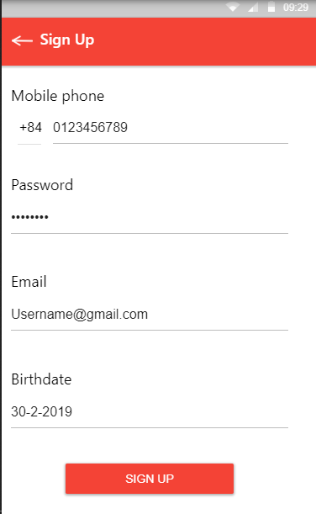Login
2. Register
3. 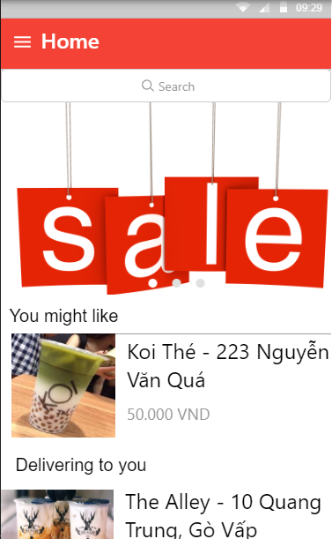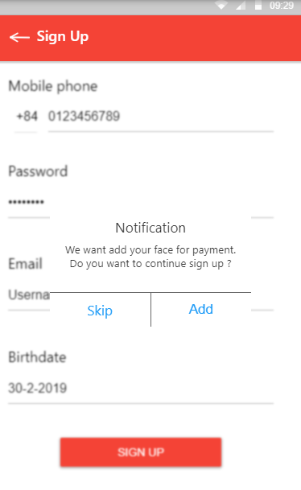Face Acceptation
4. Home
5. 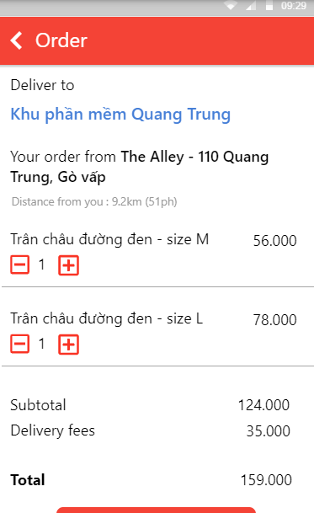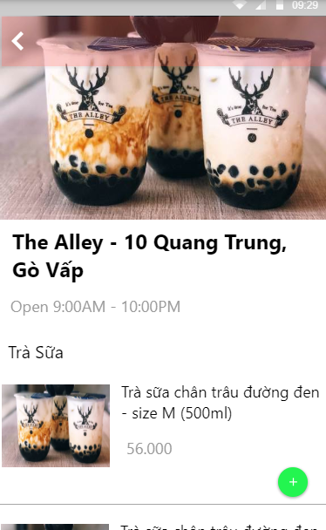Product/Store
6. Cart Order
7. 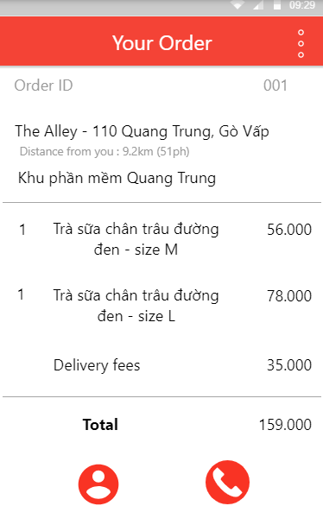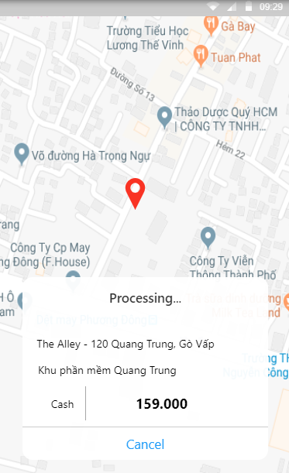Map/ Fee
8. Order Detail

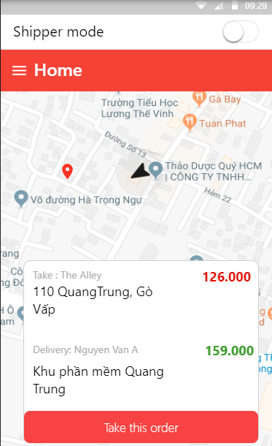

* **Shipper Mode**

1. 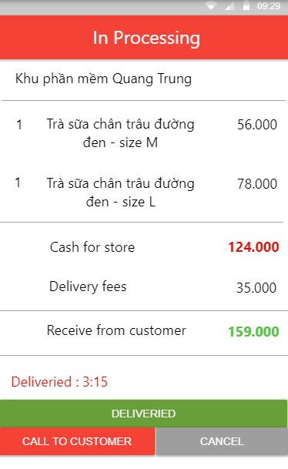Take Order
2. Order Detail
3. 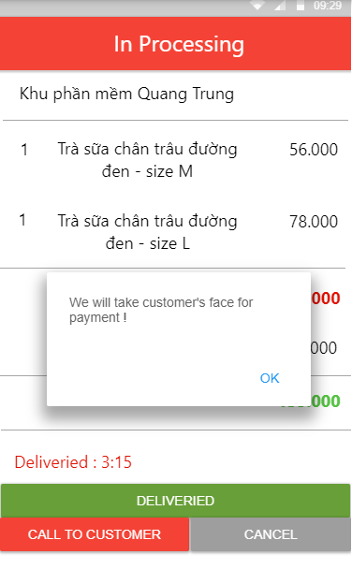Take Payment

## **5.2 Web Application**

1. 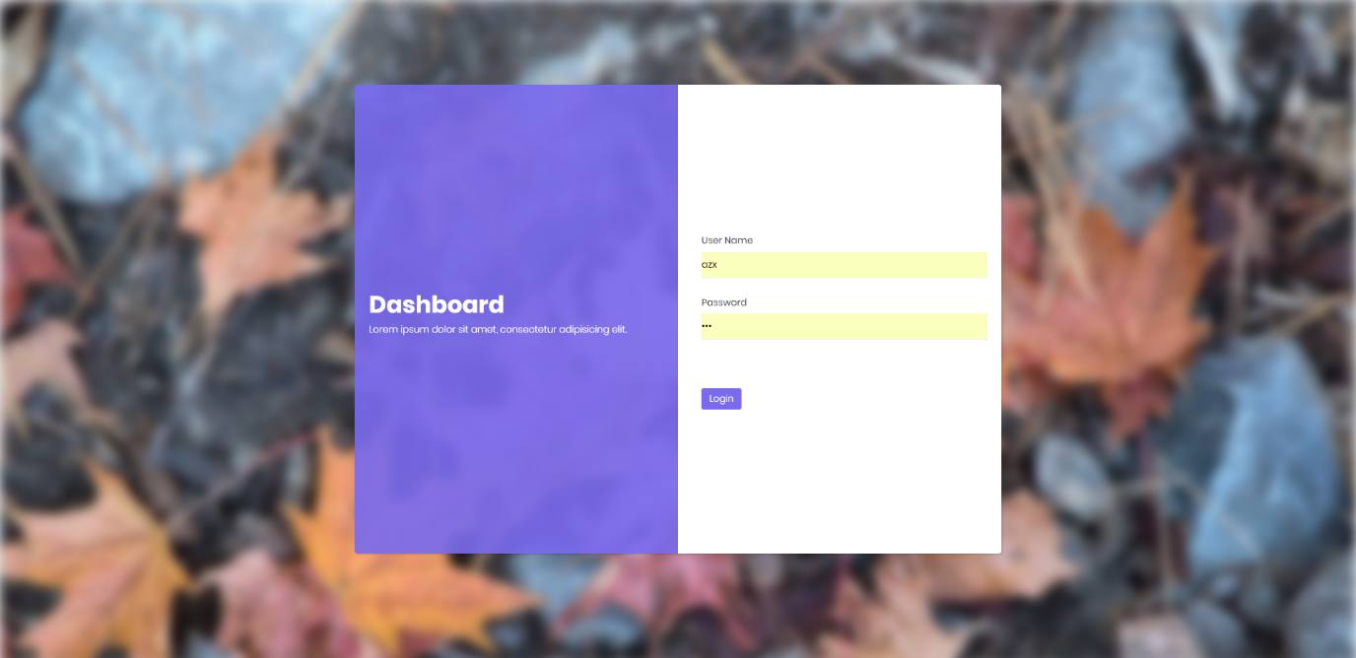Login
2. 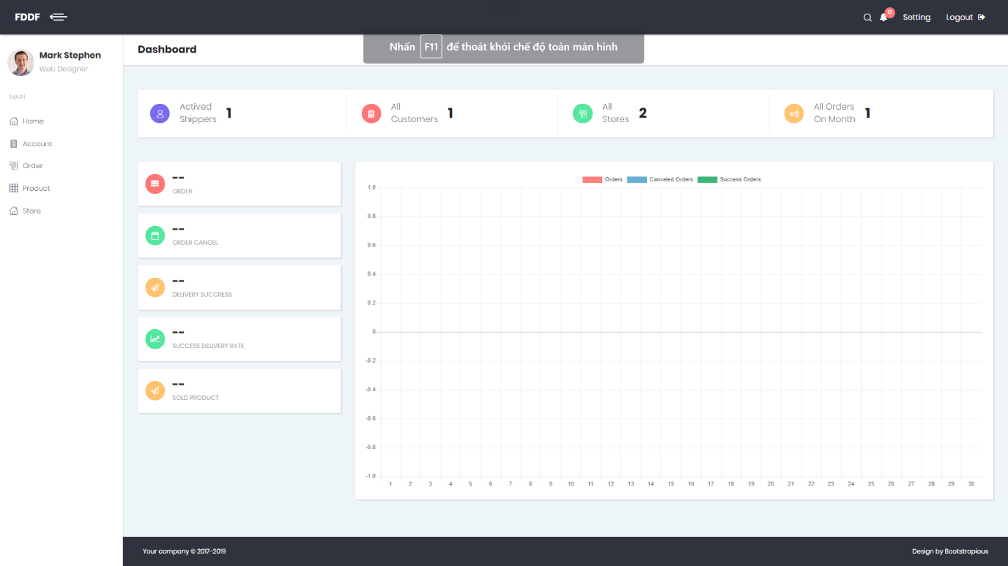Home and Statistic
3. 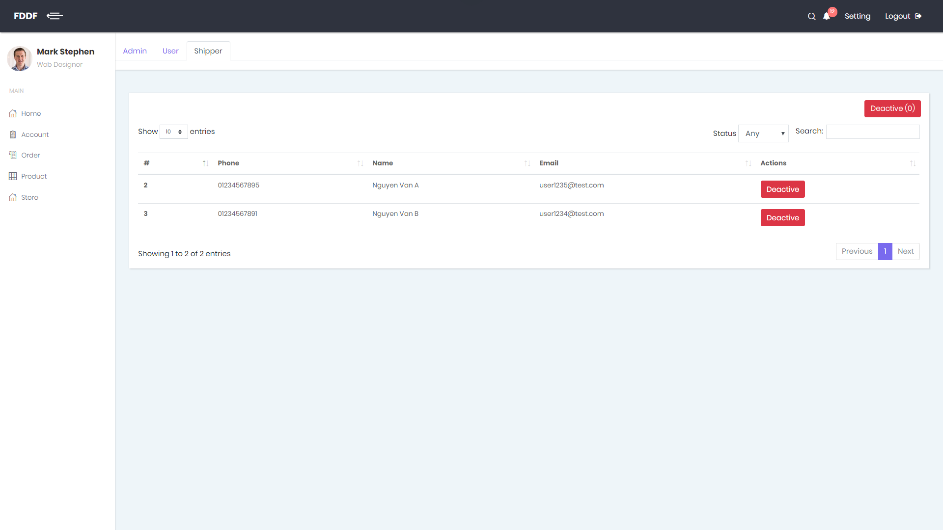Manage Account
4. 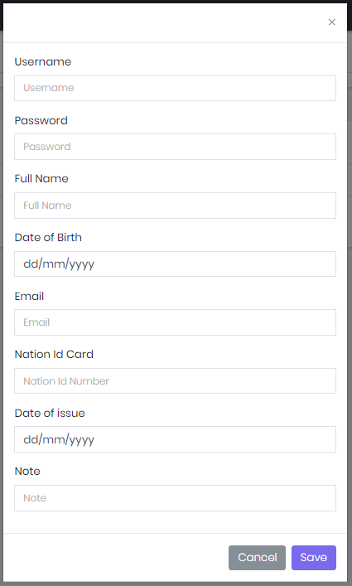Add -Detail Admin Modal
5. 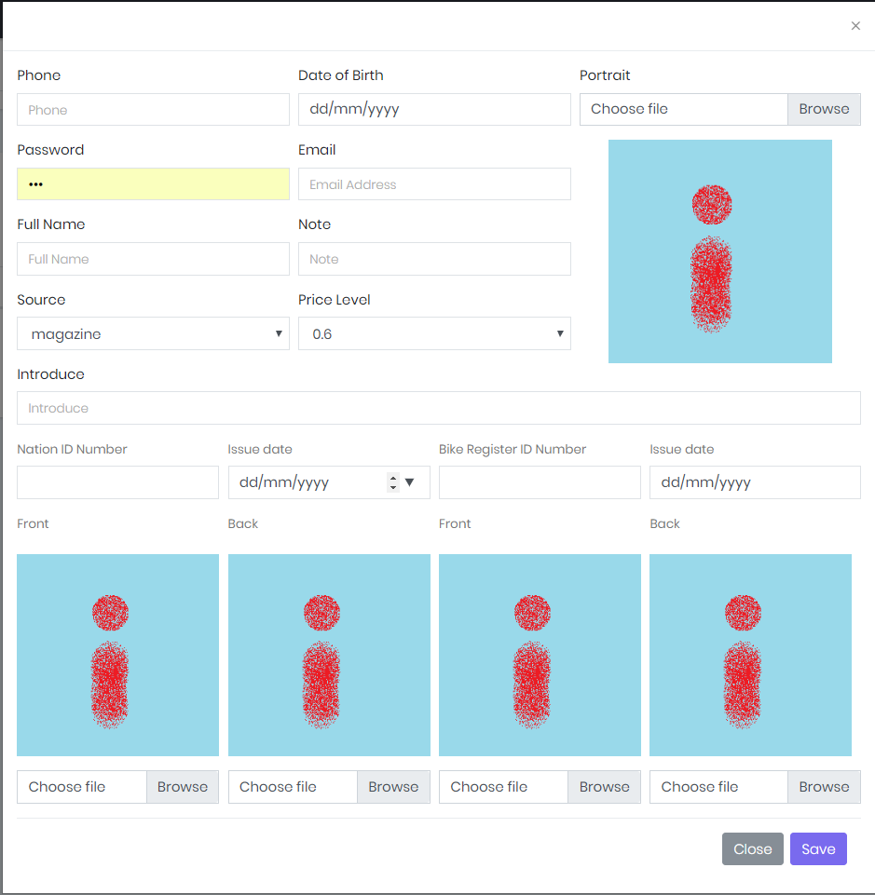Add -Detail Shipper Modal
6. 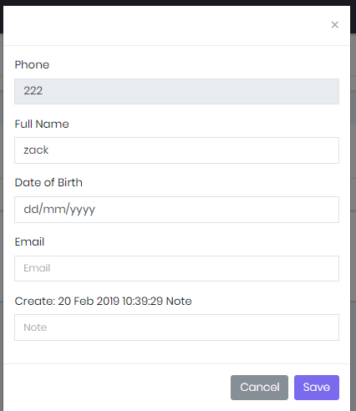Detail Customer Modal
7. 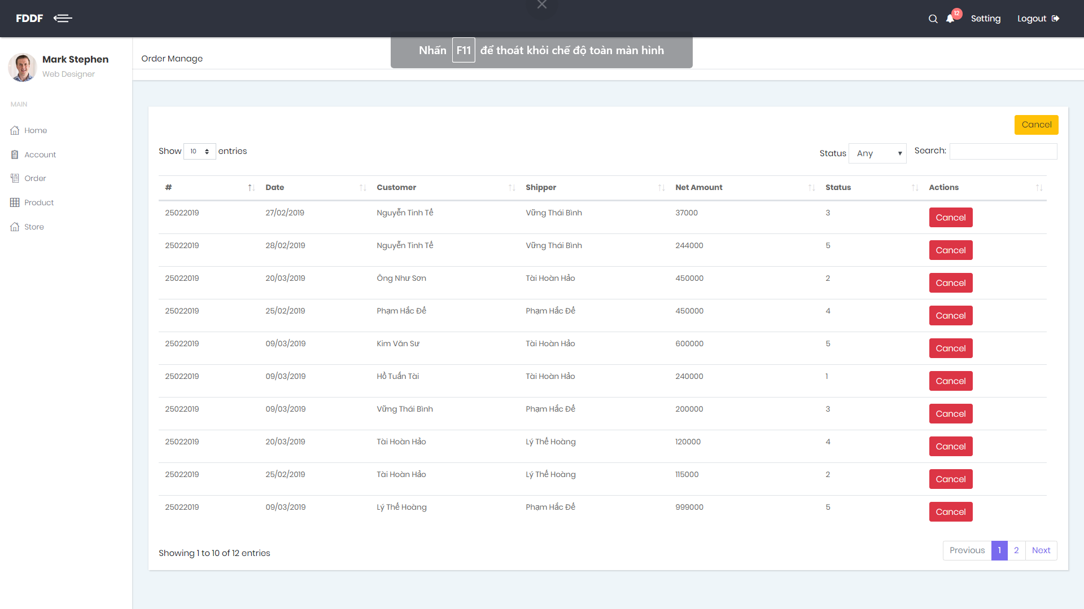Manage Order
8. 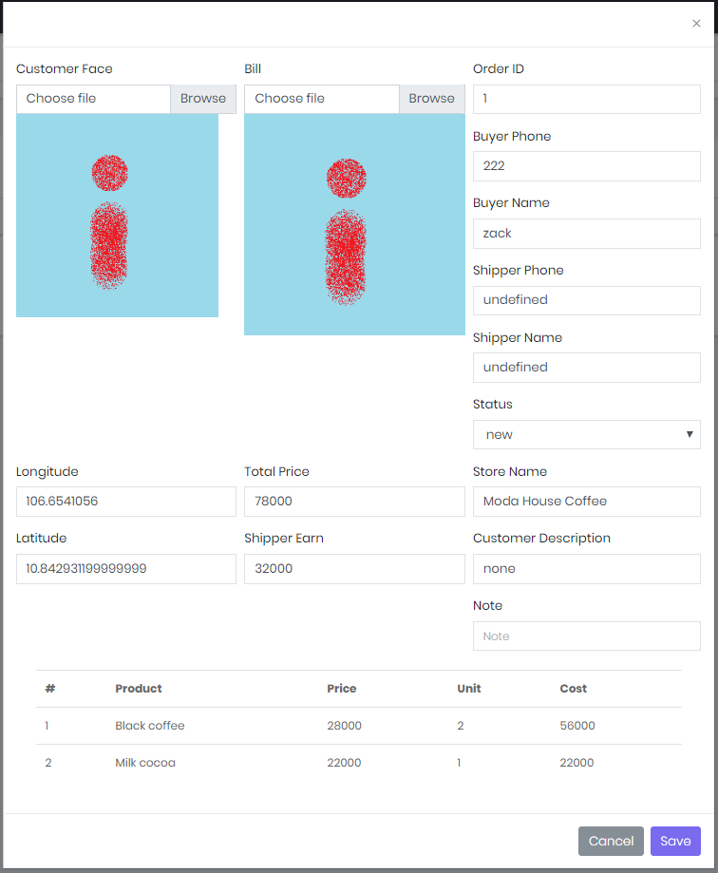Order Detail Modal
9. 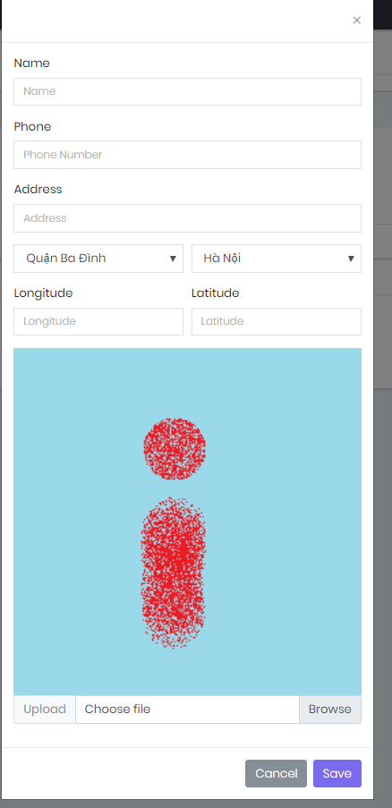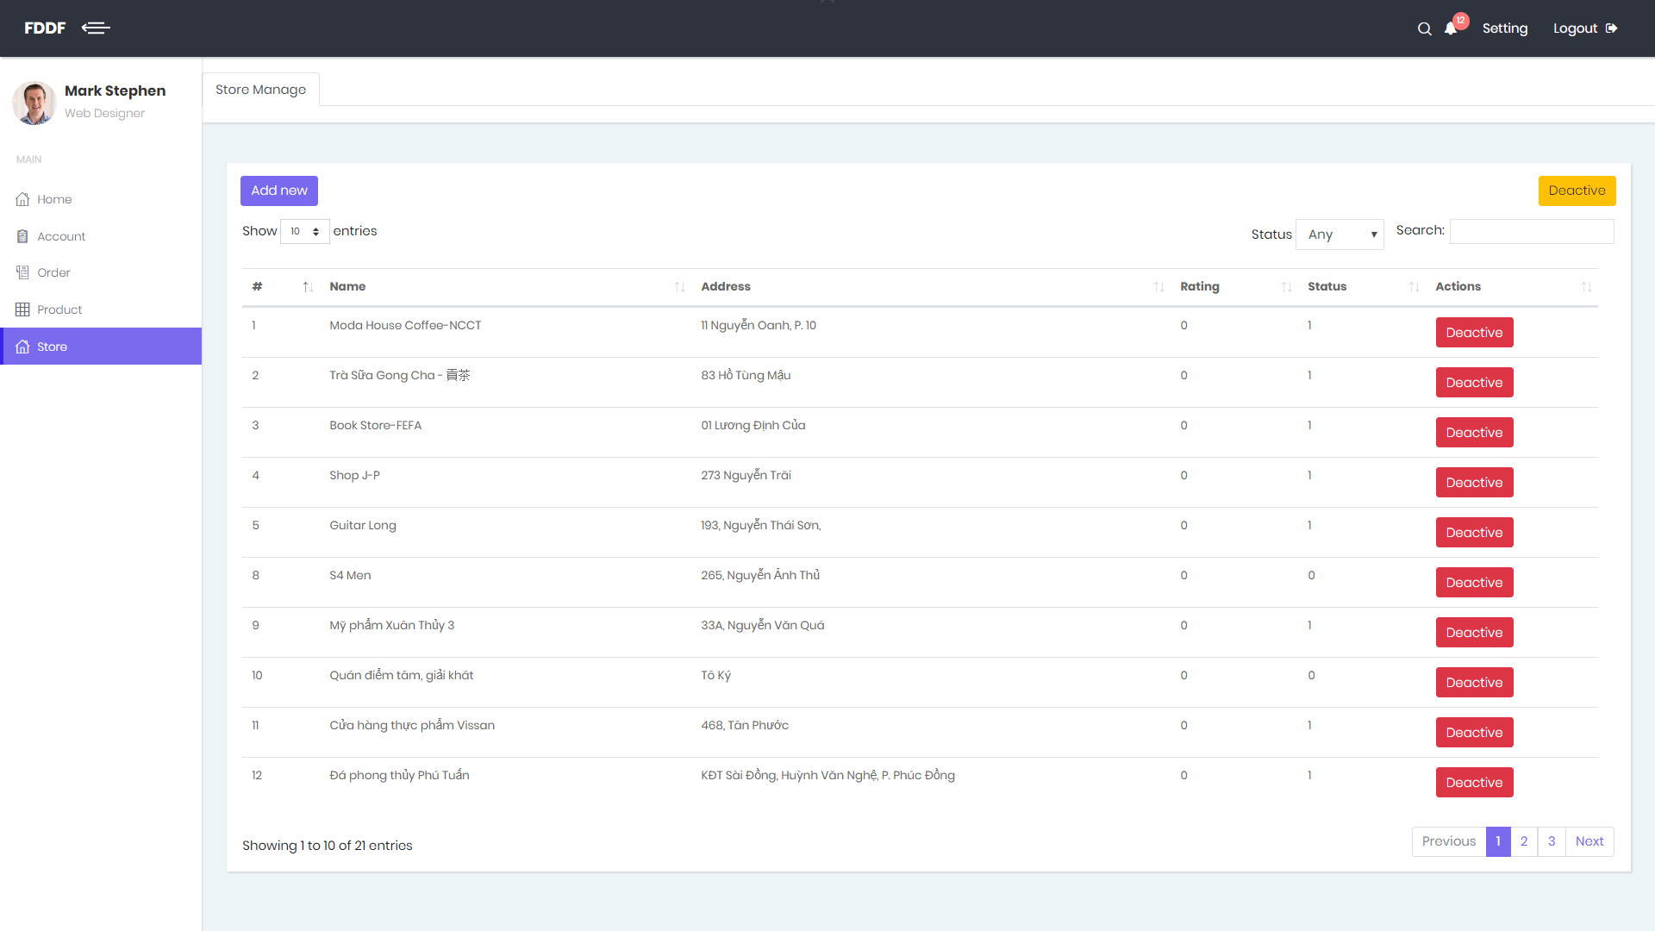Manage Store
10. Add New Store
11. 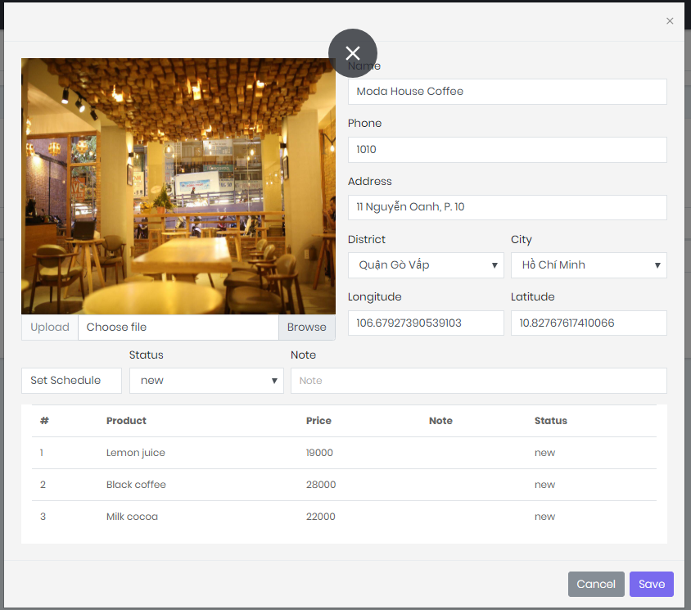Store Detail Popup
12. 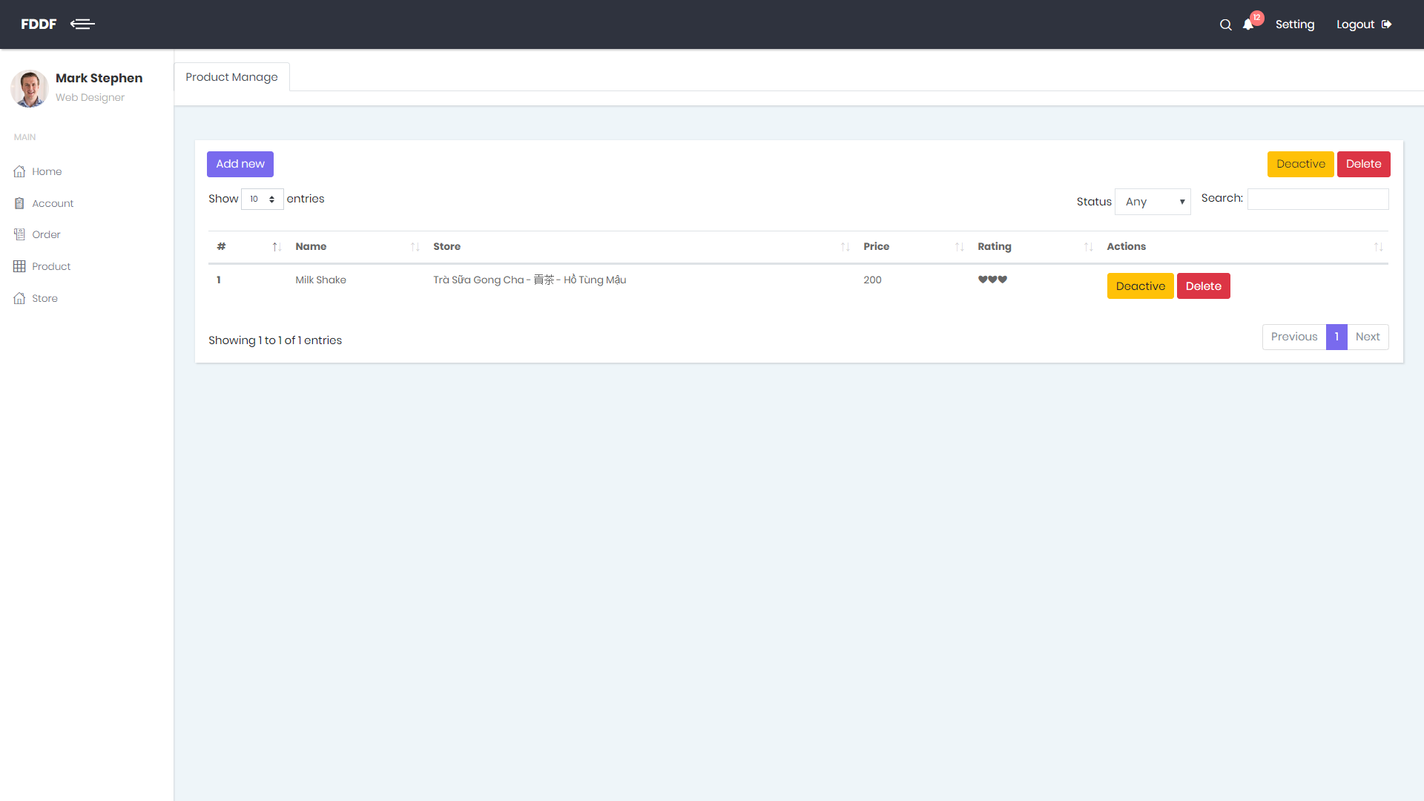Manage Product
13. 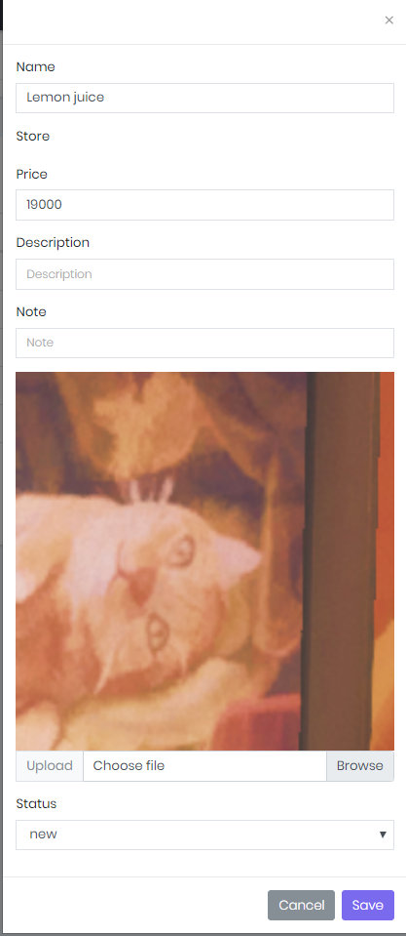Add-Detail Product Popup

# **6. Database Design**

## **6.1 Entity Relationship Diagram (ERD)**

Figure Entity Relation Diagram

## **6.2 Data Dictionary**

|  |  |  |
| --- | --- | --- |
| **Entity Data Dictionary: Describe content of all tables** | | |
| **No.** | **Table Name** | **Description** |
| 1 | Fr_account | Contain account information |
| 2 | Fr_city | Contain city information |
| 3 | Fr_district | Contain district data of city |
| 4 | Fr_order | Contain data of order’s list |
| 5 | Fr_order_detail | Contain data of order |
| 6 | Fr_payment_information | Contain data of payment |
| 7 | Fr_payment_type | Type of payment |
| 8 | Fr_price_level | Select price level for shipper |
| 9 | Fr_product | Contain data of every product of store |
| 10 | Fr_rating | Contain data rating of account for product and store |
| 11 | Fr_role | Contain data role of member |
| 12 | Fr_schedule | Contain open and close time of store |
| 13 | Fr_shipper | Contain data of shipper |
| 14 | Fr_source | Contain source of data |
| 15 | Fr_store | Contain data of store |
| 16 | Fr_weekday | Contian id for everyday (Monday, Tuesday, Sunday,…) |

Table Data Dictionary

# **7. Algorithms**